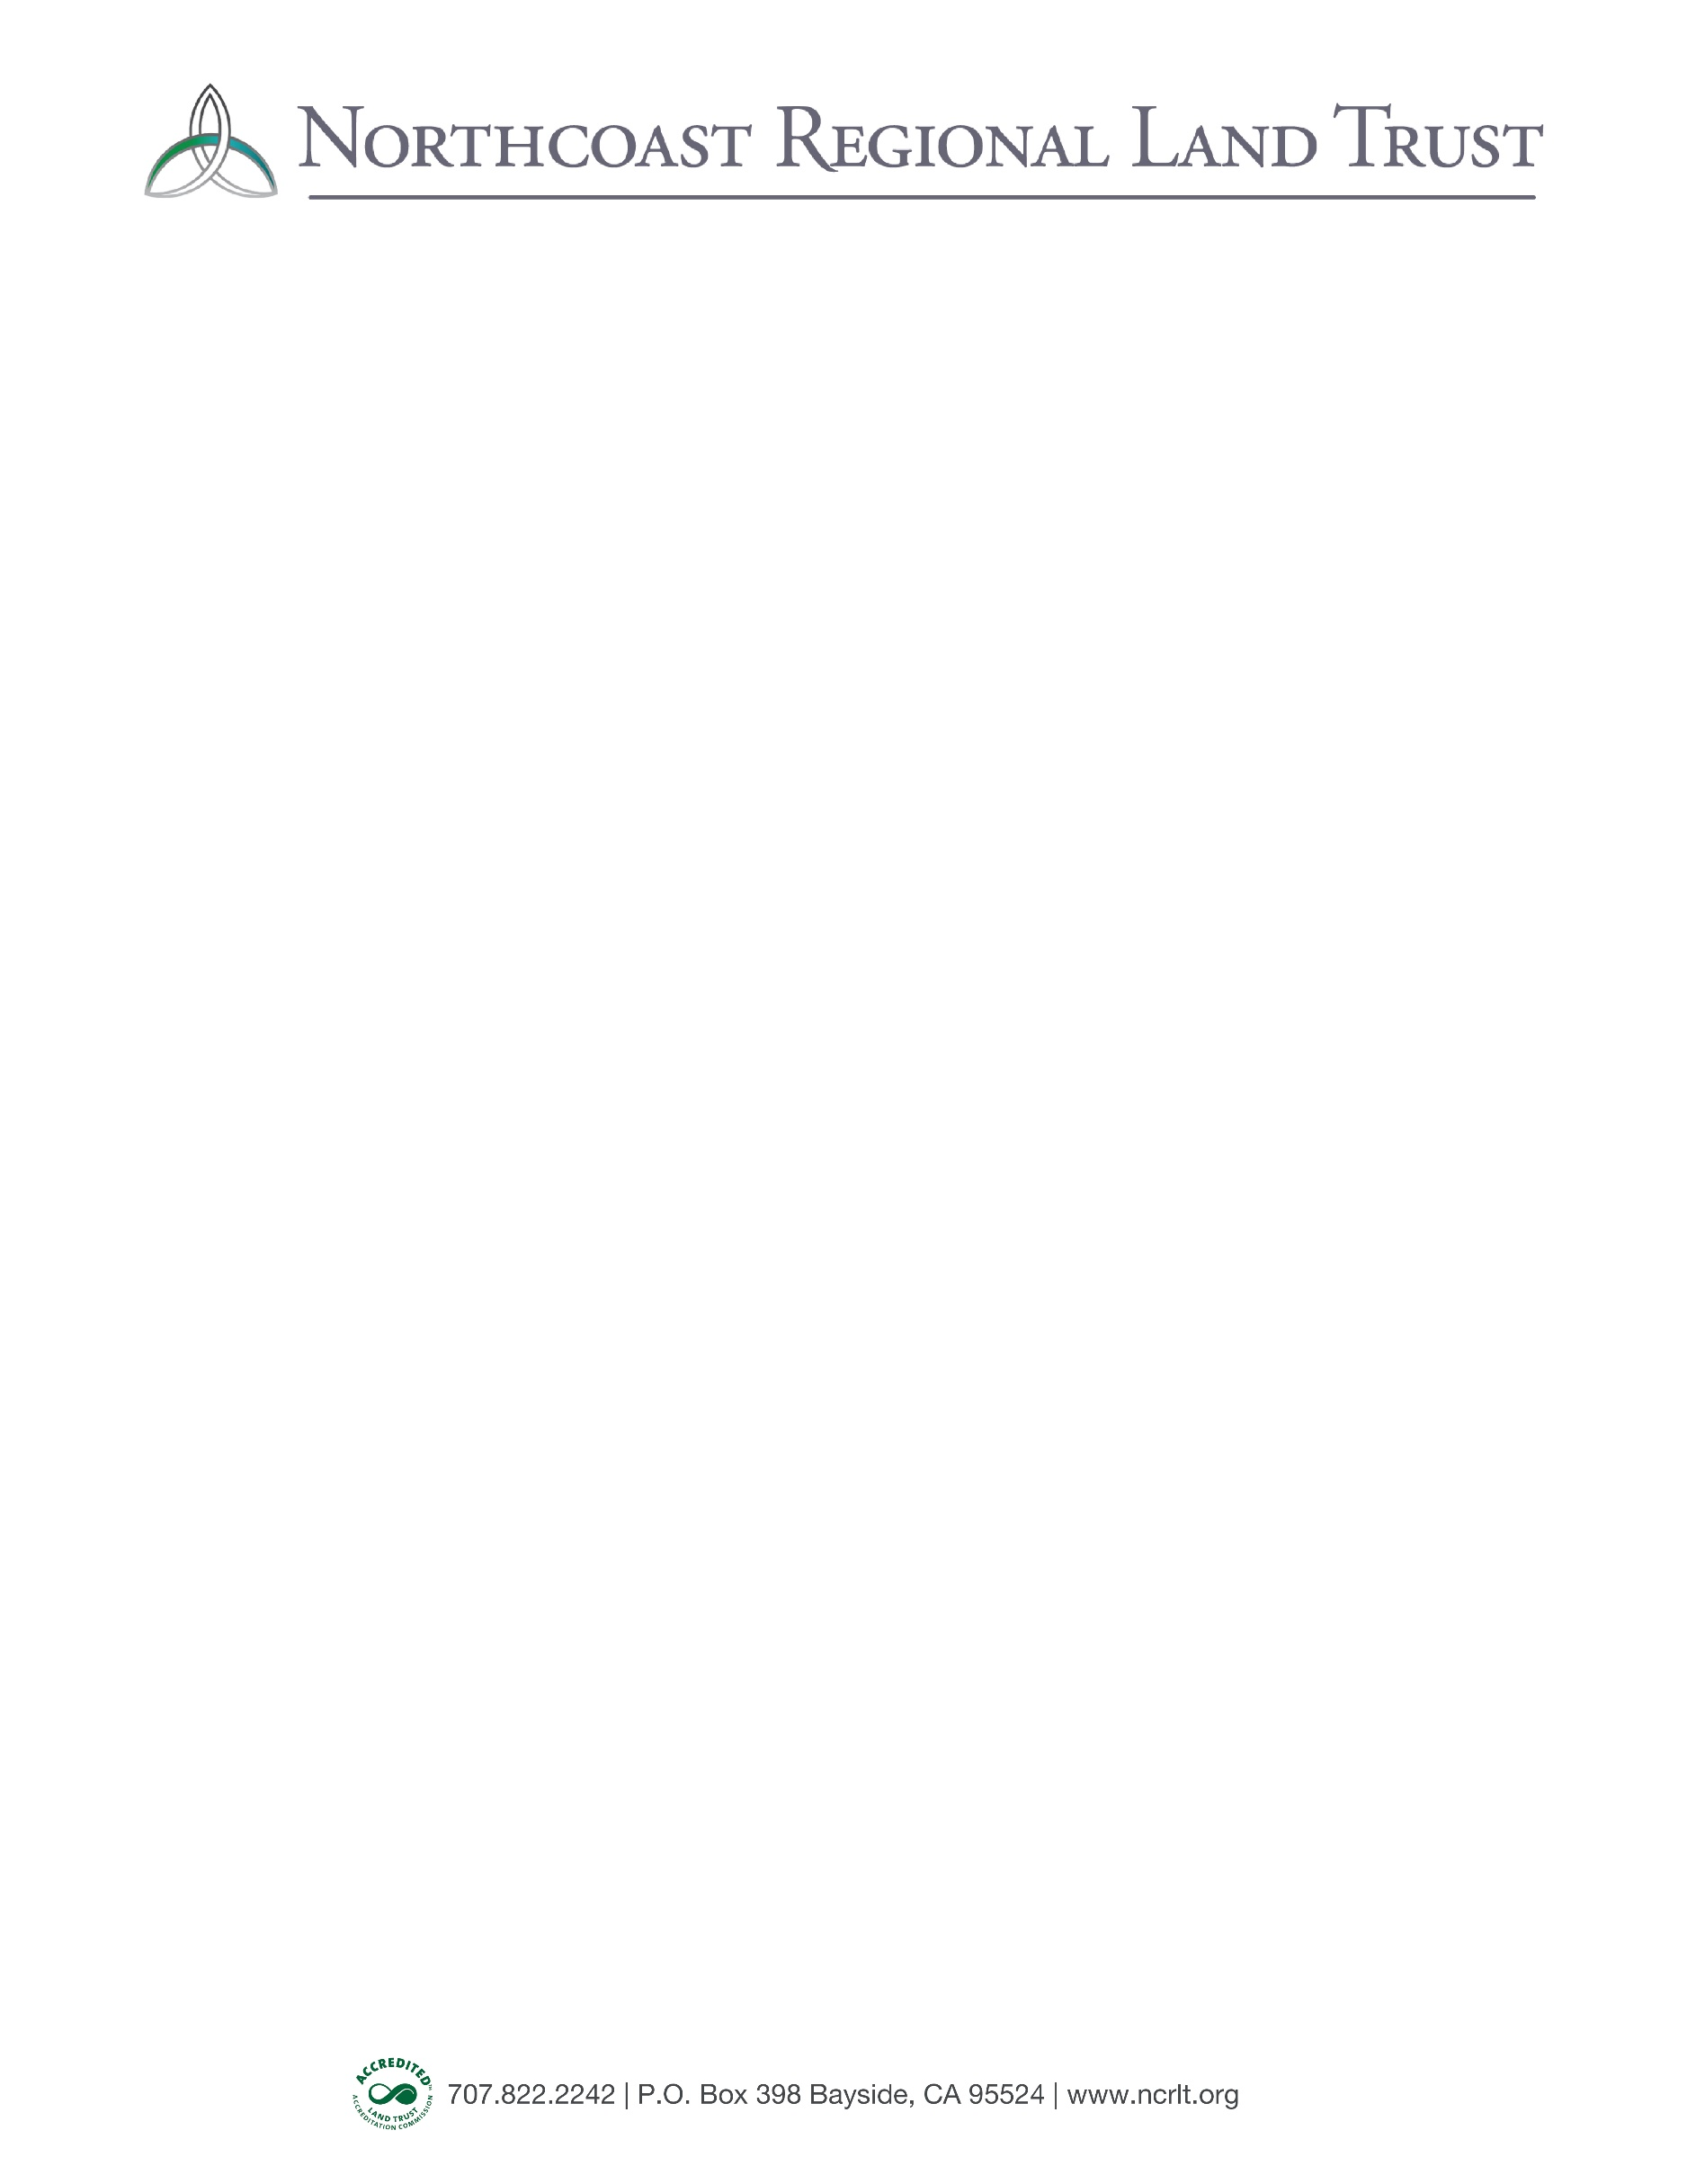
Estate Planning
STATEMENT OF INTENT

PERSONAL INFORMATION
Name(s) of Donor(s) _______________________________________________________________
Address _________________________________________________________________________
City _______________________________________ State ___________ Zip ________________
Phone _____________________ Email _______________________________________________

LEGACY (PLANNED) GIFT
I have made a provision in my estate planning to benefit the Northcoast Regional Land Trust. The provision is in the form of a:

☐ Bequest (Will or Trust)
☐ Life Insurance Policy
☐ Retirement Fund Beneficiary Designation
☐ IRA, pension, or other retirement account

☐ Other: _________________________________________________________________
Estimated Value of Estate Gift (not required): $_____________________________________
My attorney and/or financial advisor is:
Name ________________________________________________________________________
Phone ____________________ Email _____________________________________________

PURPOSE
It is my wish that the gift be used:
☐ At NRLT’s discretion, to create the greatest impact
- OR - For the following existing fund or purpose:
☐ Operations & Opportunities Fund (Organizational Endowment)
☐ Conservation Projects
☐ Outreach and Education
☐ Freshwater Farms Reserve

*If you are considering a donation of land or other real property, please connect with NRLT staff to review the details of your intended plans, and to ensure alignment with NRLT’s Gift Acceptance Policies and Conservation Plan.

IN RECOGNITION OF YOU!
NRLT appreciates the opportunity to acknowledge your commitment to wild and working lands by publicly recognizing your contribution. However, if you prefer to remain anonymous, we will respect your wishes. By notifying NRLT of your future estate plans, you are also welcomed into our ‘Legacy Society,’ and will receive invitations to VIP events.
☐ I (we) permit NRLT to use my/our name(s) in printed lists of planned gifts, which may appear in NRLT’s annual report, newsletter, website and/or other publications.
☐ I (we) prefer to remain anonymous during my/our lifetime(s). You may recognize me/our gift after you receive it.
☐ I (we) prefer to remain anonymous during and after my/our lifetime(s).
Name(s) as you wish to be listed:
________________________________________________________________________________

SAMPLE LANGUAGE FOR YOUR WILL OR TRUST
Please share with your estate attorney, financial planner, other professional advisor, and your administrator or executor:
I give to the Northcoast Regional Land Trust,
a nonprofit 501(c)(3) organization currently headquartered
in Bayside, CA EIN #68-0456290, $(amount) or (percentage)
I/we understand that, by stating an amount, this statement does not legally bind my/our estate, and that I/we may choose to add, subtract, or revoke this bequest at any time at my/our sole discretion.

Donor Signature _________________________________________________ Date ___________

Donor Signature _________________________________________________ Date ___________

Thank you for your commitment to wild and working lands
and your investment in our community’s future!

Please return your form by email or mail to:
Nadia Van Lynn, Outreach and Development Manager, Northcoast Regional Land Trust
PO Box 398, Bayside, CA 95524 | (707)822-2242 | n.vanlynn@ncrlt.org

